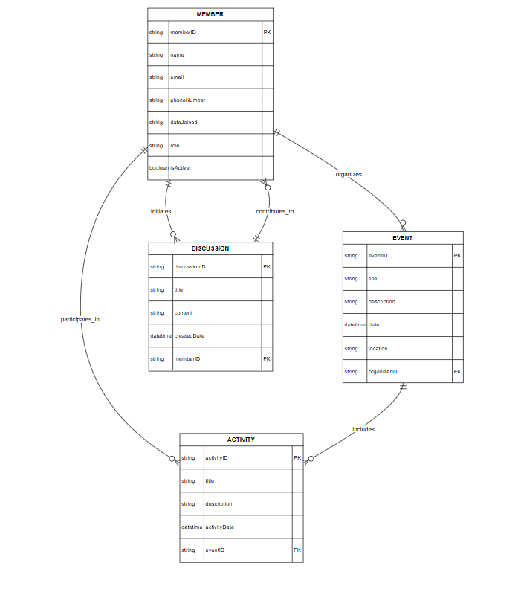

**Entities and attributes:**

1. **MEMBER**
   * memberID (PK)
   * name
   * email
   * phoneNumber
   * dateJoined
   * role
   * isActive (boolean)
2. **DISCUSSION**
   * discussionID (PK)
   * title
   * content
   * createdDate
   * memberID (FK → MEMBER)
3. **EVENT**
   * eventID (PK)
   * title
   * description
   * date
   * location
   * organizerID (FK → MEMBER)
4. **ACTIVITY**
   * activityID (PK)
   * title
   * description
   * activityDate
   * eventID (FK → EVENT)